# Benchmark Performance Overhead and space utilization

## Performance

### Execution Time

* **Implement Precise Timing**: Within your application code, use precise timing functions like System.nanoTime() in Java or clock_gettime() in C/C++ to measure the start and end times of specific operations, especially those that are memory-intensive.
* **Run Both Variants:** Execute both the MTE-enabled and MTE-disabled variants under identical conditions. This might involve specific user interactions or automated scripts that drive the application in a consistent manner.
* **Calculate Overhead:** Determine the execution time differences for operations between the two variants to assess the performance overhead introduced by MTE.

***1000 iterations, tests memory intensive operations***

MTE Enabled (Mode Set to sync): **= 0.01633989**

1st trial: MTE fully enabled in Developer Settings = **0.0134**

* = 0.013225 s
* = 0.017159 s
* = 0.009816 s

2nd trial: enabled once **= 0.01878967**

* = 0.022536 s
* = 0.017004 s
* = 0.016829 s

3rd trial: MTE fully enabled in Developer Settings = **0.01683**

* = 0.016921 s
* = 0.016821 s
* = 0.016748 s

MTE Enabled (Mode Set to async): **= 0.004349113**

1st trial: MTE fully enabled in Developer Settings = 0.00264867

* = 0.002731 s
* = 0.002734 s
* = 0.002481 s

2nd trial: enabled once **= 0.004901**

* = 0.004890 s
* = 0.004932 s
* = 0.004881 s

3rd trial: MTE fully enabled in Developer Settings **= 0.00549767**

* = 0.006493 s
* = 0.005083 s
* = 0.004917 s

MTE Semi-Disabled (Mode Set to OFF): **= 0.00276219**

1st trial: MTE fully enabled in Developer Settings **= 0.00224367**

* = 0.002249 s
* = 0.002240 s
* = 0.002242 s

2nd trial: enabled once **= 0.0035743**

* = 0.005064 s
* = 0.002778 s
* = 0.002881 s

3rd trial: MTE fully enabled in Developer Settings **= 0.0024686**

* = 0.002476 s
* = 0.002438 s
* = 0.002492 s

MTE Disabled Completely (Turned off in Developer Settings): = **0.005623767**

1st trial: MTE fully enabled in Developer Settings **= 0.005679**

* = 0.005125 s
* = 0.006783 s
* = 0.005129 s

2nd trial: enabled once (after reset, meaning no MTE) **= 0.0054923**

* = 0.005112 s
* = 0.006265 s
* = 0.005100 s

3rd trial: MTE fully disabled in Developer Settings with MTE mode set to off **= 0.0057**

* = 0.005146 s
* = 0.006778 s
* = 0.005176 s

#### Results

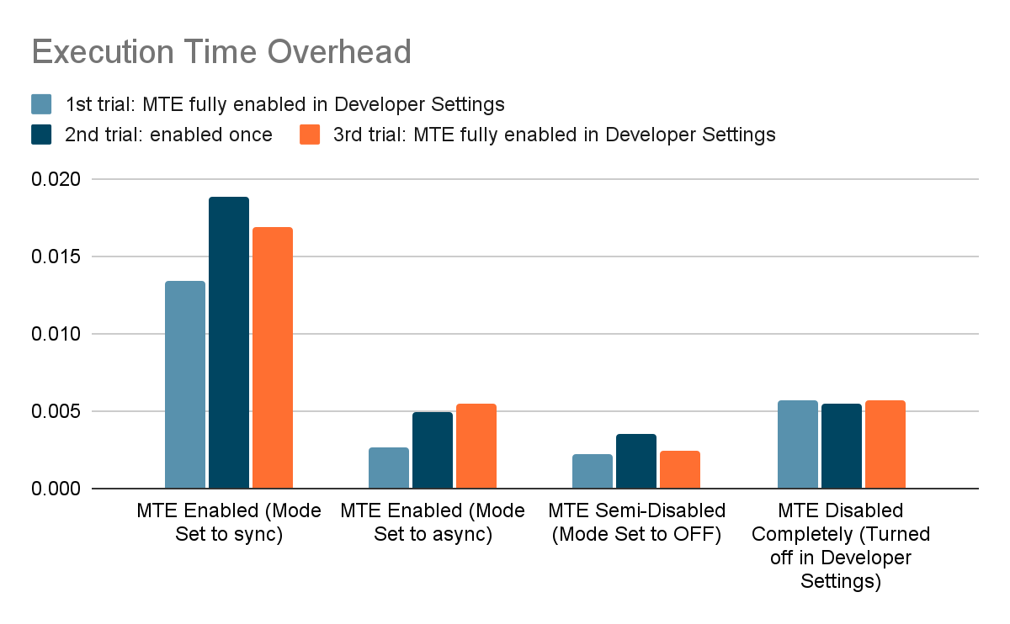

* **MTE Disabled Completely vs MTE Enabled (Mode Set to sync):** MTE Disabled is approximately **3x faster** than when MTE is Enabled in Sync mode.
* **MTE Disabled Completely vs MTE Enabled (Mode Set to async):** MTE Disabled is approximately **1.29x slower** than when MTE is Enabled in Async mode.
* **MTE Disabled Completely vs MTE Semi-Disabled (Mode Set to OFF):** MTE Disabled is approximately **2x slower** than when MTE is Semi-Disabled.

#### Takeaways

* ASync vs Sync Performance Impact
* Semi-disabled performing better than both fully enabled and completely disabled states is weird
* Variability Within Trials
* SECURITY:
  + Async mode potentially introduces risks
  + Semi-Disabled Security - suggest a reduction in MTE's operational scope. What specific protections are disabled in this mode, and how might this open avenues for memory safety exploits?
  + Could preferences for faster execution times over strict memory safety checks lead to under-detected vulnerabilities in real-world applications?

## CPU and Memory Usage

### Test 1: Regular testing power analysis

MTE Mode Sync:

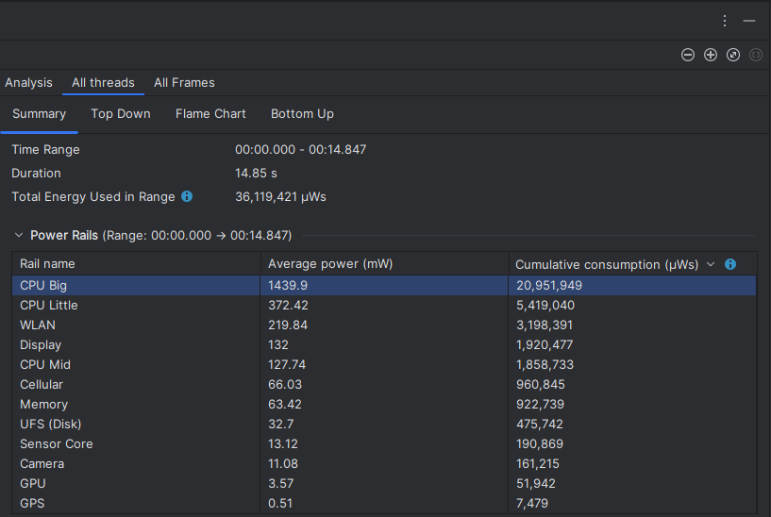

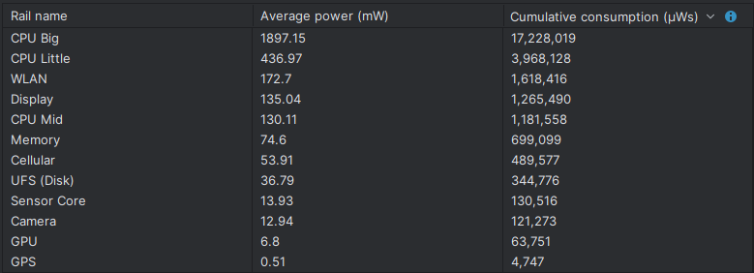

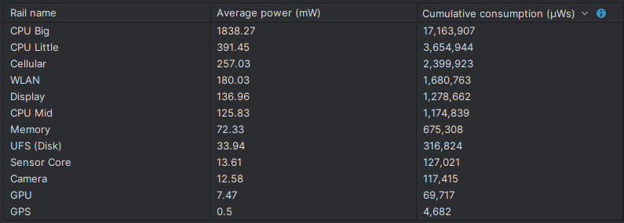

Native Memory Sampling Interval at 2048 bytes



Native Memory Sampling Interval at 1024 bytes



Native Memory Sampling Interval at 512 dobytes



MTE Mode Async:

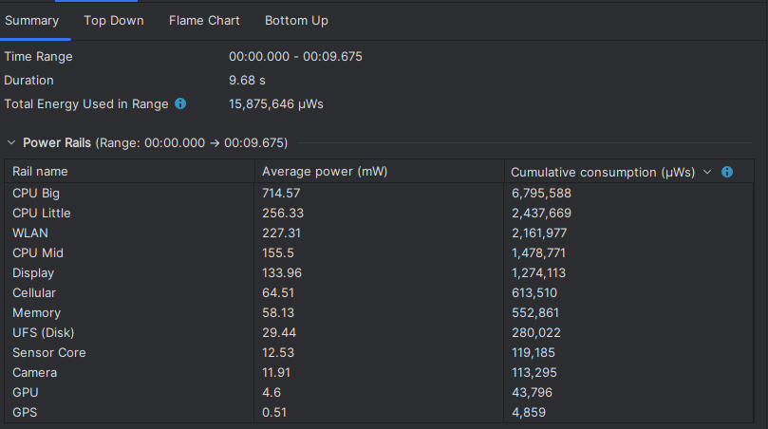

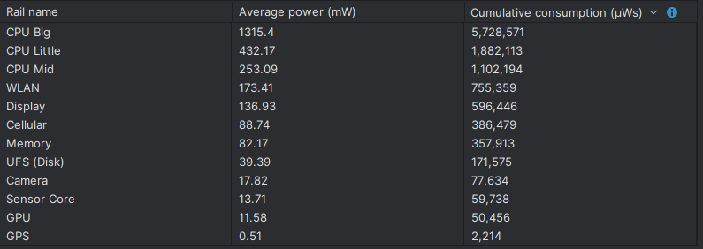

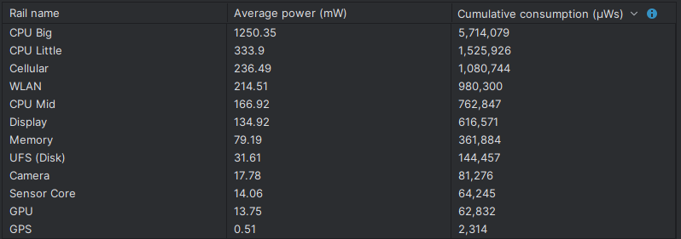

Native Memory Sampling Interval at 2048 bytes



MTE Mode Off:

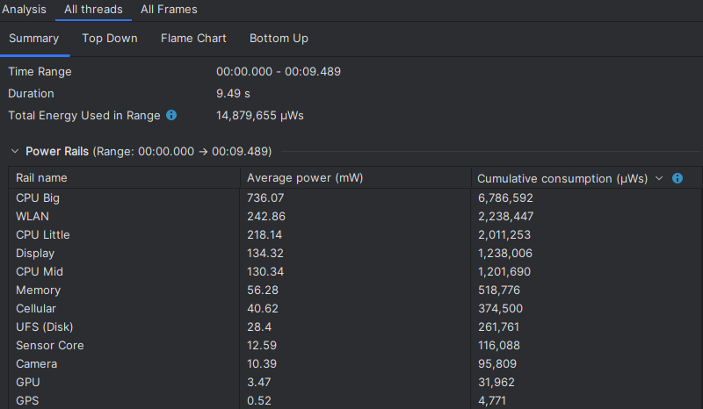

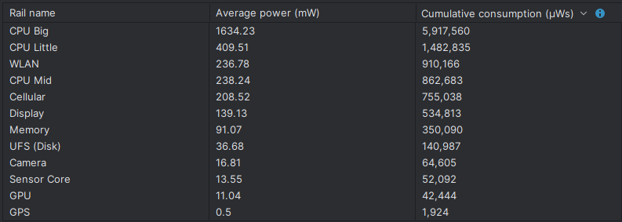

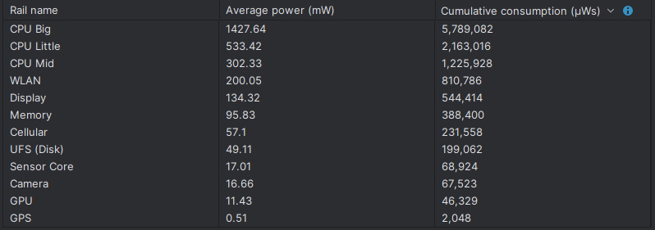

Native Memory Sampling Interval at 2048 bytes



MTE Disabled:

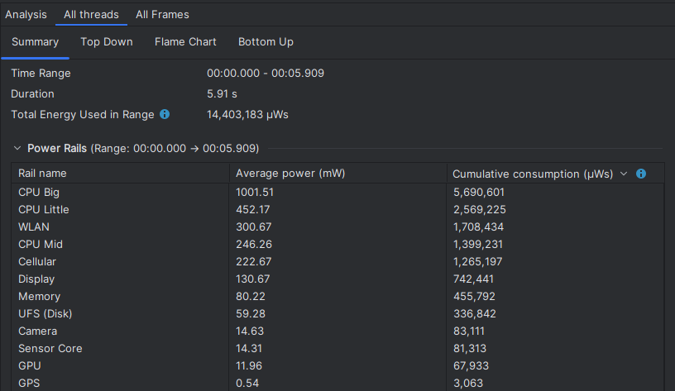

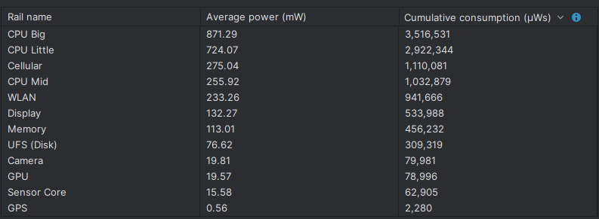

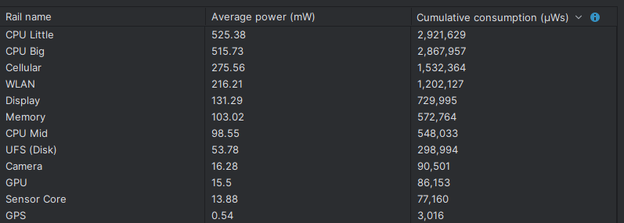

Native Memory Sampling Interval at 2048 bytes



Native Memory Sampling Interval at 512 bytes



#### Results

30,687,000 (MTE sync mode) is a **156.57% increase** of 11,960,000 (MTE disabled)

12,744,000 (MTE async and ~ MTE off) is a **6.5552% increase** of 11,960,000 (MTE disabled).

### Test 2: Memory Usage via adb shell dumpsys meminfo - Basic Benchmark Code

#### MTE Enabled (Sync):

Applications Memory Usage (in Kilobytes):

Uptime: 73330 Realtime: 73330

Total RAM: 7,534,128K (status normal)

Free RAM: 2,735,121K (1,565,457K cached pss + 717,844K cached kernel + 451,820K free)

DMA-BUF: 194,184K ( 27,980K mapped + 166,204K unmapped)

DMA-BUF Heaps: 194,184K

DMA-BUF Heaps pool: 62,233K

GPU: 336,848K ( 120,868K dmabuf + 215,980K private)

Used RAM: 4,210,277K (2,940,769K used pss + 1,269,508K kernel)

Lost RAM: 1,128,337K

ZRAM: 229,828K physical used for 805,632K in swap (3,767,060K total swap)

Tuning: 256 (large 512), oom 322,560K, restore limit 107,520K (high-end-gfx)

#### MTE Enabled (Async):

Applications Memory Usage (in Kilobytes):

Uptime: 697076 Realtime: 697076

Total RAM: 7,534,128K (status normal)

Free RAM: 2,853,680K (1,697,388K cached pss + 743,424K cached kernel + 412,868K free)

DMA-BUF: 193,732K ( 27,948K mapped + 165,784K unmapped)

DMA-BUF Heaps: 193,732K

DMA-BUF Heaps pool: 24,577K

GPU: 318,236K ( 120,564K dmabuf + 197,672K private)

Used RAM: 4,080,585K (2,828,533K used pss + 1,252,052K kernel)

Lost RAM: 1,296,734K

ZRAM: 269,528K physical used for 990,464K in swap (3,767,060K total swap)

Tuning: 256 (large 512), oom 322,560K, restore limit 107,520K (high-end-gfx)

#### MTE Enabled (Off):

Applications Memory Usage (in Kilobytes):

Uptime: 753839 Realtime: 753839

Total RAM: 7,534,128K (status normal)

Free RAM: 3,051,093K (1,778,801K cached pss + 799,320K cached kernel + 472,972K free)

DMA-BUF: 193,732K ( 27,948K mapped + 165,784K unmapped)

DMA-BUF Heaps: 193,732K

DMA-BUF Heaps pool: 62,489K

GPU: 305,512K ( 120,564K dmabuf + 184,948K private)

Used RAM: 3,899,774K (2,659,398K used pss + 1,240,376K kernel)

Lost RAM: 1,317,976K

ZRAM: 322,884K physical used for 1,109,504K in swap (3,767,060K total swap)

Tuning: 256 (large 512), oom 322,560K, restore limit 107,520K (high-end-gfx)

#### MTE Disabled:

Applications Memory Usage (in Kilobytes):

Uptime: 178986 Realtime: 178986

Total RAM: 7,785,788K (status normal)

Free RAM: 2,976,162K (1,754,826K cached pss + 791,040K cached kernel + 430,296K free)

DMA-BUF: 194,316K ( 28,012K mapped + 166,304K unmapped)

DMA-BUF Heaps: 194,316K

DMA-BUF Heaps pool: 68,593K

GPU: 345,516K ( 138,672K dmabuf + 206,844K private)

Used RAM: 4,060,027K (2,785,043K used pss + 1,274,984K kernel)

Lost RAM: 1,410,475K

ZRAM: 274,548K physical used for 978,688K in swap (3,892,888K total swap)

Tuning: 256 (large 512), oom 322,560K, restore limit 107,520K (high-end-gfx)

## Test 3: Memory Usage via adb shell dumpsys meminfo - Complex Benchmark

#### MTE Enabled (Sync):

Applications Memory Usage (in Kilobytes):

Uptime: 1073532 Realtime: 1073532

Total RAM: 7,534,128K (status normal)

Free RAM: 3,084,726K (1,917,470K cached pss + 805,992K cached kernel + 361,264K free)

DMA-BUF: 193,732K ( 27,948K mapped + 165,784K unmapped)

DMA-BUF Heaps: 193,732K

DMA-BUF Heaps pool: 62,489K

GPU: 305,692K ( 120,564K dmabuf + 185,128K private)

Used RAM: 3,873,702K (2,628,762K used pss + 1,244,940K kernel)

Lost RAM: 1,328,811K

ZRAM: 322,896K physical used for 1,125,376K in swap (3,767,060K total swap)

Tuning: 256 (large 512), oom 322,560K, restore limit 107,520K (high-end-gfx)

#### MTE Enabled (Async):

Applications Memory Usage (in Kilobytes):

Uptime: 1095869 Realtime: 1095869

Total RAM: 7,534,128K (status normal)

Free RAM: 3,015,994K (1,754,750K cached pss + 806,564K cached kernel + 454,680K free)

DMA-BUF: 193,732K ( 27,948K mapped + 165,784K unmapped)

DMA-BUF Heaps: 193,732K

DMA-BUF Heaps pool: 62,489K

GPU: 305,820K ( 120,564K dmabuf + 185,256K private)

Used RAM: 3,937,228K (2,689,868K used pss + 1,247,360K kernel)

Lost RAM: 1,333,133K

ZRAM: 320,700K physical used for 1,125,376K in swap (3,767,060K total swap)

Tuning: 256 (large 512), oom 322,560K, restore limit 107,520K (high-end-gfx)

#### MTE Enabled (Off):

Applications Memory Usage (in Kilobytes):

Uptime: 1119229 Realtime: 1119229

Total RAM: 7,534,128K (status normal)

Free RAM: 2,976,325K (1,784,809K cached pss + 808,516K cached kernel + 383,000K free)

DMA-BUF: 193,732K ( 27,948K mapped + 165,784K unmapped)

DMA-BUF Heaps: 193,732K

DMA-BUF Heaps pool: 62,489K

GPU: 305,692K ( 120,564K dmabuf + 185,128K private)

Used RAM: 3,969,862K (2,722,630K used pss + 1,247,232K kernel)

Lost RAM: 1,312,552K

ZRAM: 316,936K physical used for 1,093,376K in swap (3,767,060K total swap)

Tuning: 256 (large 512), oom 322,560K, restore limit 107,520K (high-end-gfx)

#### MTE Disabled:

Applications Memory Usage (in Kilobytes):

Uptime: 194689 Realtime: 194689

Total RAM: 7,785,788K (status normal)

Free RAM: 3,059,492K (1,744,904K cached pss + 787,624K cached kernel + 526,964K free)

DMA-BUF: 187,536K ( 28,004K mapped + 159,532K unmapped)

DMA-BUF Heaps: 187,536K

DMA-BUF Heaps pool: 101,133K

GPU: 319,376K ( 121,212K dmabuf + 198,164K private)

Used RAM: 4,239,454K (3,007,770K used pss + 1,231,684K kernel)

Lost RAM: 969,897K

ZRAM: 256,348K physical used for 802,816K in swap (3,892,888K total swap)

Tuning: 256 (large 512), oom 322,560K, restore limit 107,520K (high-end-gfx)

## Test 3: using top

### Actively running code

Tasks: 897 total, 2 running, 895 sleeping, 0 stopped, 0 zombie

Mem: 7534128K total, 6873000K used, 661128K free, 2320K buffers

Swap: 3767060K total, 1599412K used, 2167648K free, 2102260K cached

900%cpu 12%user 0%nice 33%sys 812%idle 0%iow 38%irq 5%sirq 0%host

PID USER PR NI VIRT RES SHR S[%CPU] %MEM TIME+ ARGS

1075 nobody 20 0 10G 9.1M 7.2M R 11.3 0.1 0:28.34 traced_probes

26019 u0_a271 10 -10 16G 137M 73M S 6.3 1.8 0:03.88 com.example.mtestudy_benchmarking

1638 system 18 -2 22G 623M 476M S 3.0 8.4 9:12.35 system_server

955 system 20 0 10G 4.9M 4.2M S 3.0 0.0 0:14.86 android.hardware.power.stats-service.pixel

630 system 12 -8 11G 11M 7.5M S 3.0 0.1 1:06.38 android.hardware.composer.hwc3-service.pixel

24699 shell 20 0 10G 3.1M 2.5M S 2.0 0.0 0:06.84 process-tracker --interval 1000

26073 root 20 0 10G 5.6M 3.9M R 1.6 0.0 0:00.08 top

1081 nobody 20 0 10G 14M 4.9M S 1.6 0.1 0:06.06 traced

24395 root 20 0 0 0 0 I 1.3 0.0 0:02.25 [kworker/u18:15-events_unbound]

9030 root 20 0 0 0 0 I 1.3 0.0 0:18.52 [kworker/3:5-memlat_wq]

8930 root 20 0 0 0 0 I 1.3 0.0 0:18.55 [kworker/2:4-memlat_wq]

964 system 20 0 11G 7.0M 5.5M S 1.3 0.0 0:29.36 android.hardware.sensors-service.multihal

24158 root 20 0 0 0 0 I 1.0 0.0 0:01.44 [kworker/0:1-memlat_wq]

24592 root 20 0 0 0 0 I 0.6 0.0 0:01.63 [kworker/5:6-mm_percpu_wq]

3172 root 20 0 0 0 0 I 0.6 0.0 0:06.96 [kworker/1:4-memlat_wq]

9378 root 20 0 0 0 0 I 0.6 0.0 0:23.29 [kworker/u18:20-async_vote_wq]

### Stopping the code

Tasks: 873 total, 1 running, 872 sleeping, 0 stopped, 0 zombie

Mem: 7534128K total, 6984320K used, 549808K free, 2320K buffers

Swap: 3767060K total, 1586100K used, 2180960K free, 2193248K cached

900%cpu 11%user 0%nice 24%sys 857%idle 0%iow 4%irq 3%sirq 0%host

PID USER PR NI VIRT RES SHR S[%CPU] %MEM TIME+ ARGS

1075 nobody 20 0 10G 9.1M 7.2M S 9.0 0.1 0:39.45 traced_probes

630 system 12 -8 11G 11M 7.5M S 4.3 0.1 1:09.10 android.hardware.composer.hwc3-service.pixel

1638 system 18 -2 22G 650M 479M S 3.0 8.8 9:17.05 system_server

955 system 20 0 10G 4.9M 4.2M S 2.6 0.0 0:17.27 android.hardware.power.stats-service.pixel

9378 root 20 0 0 0 0 I 2.0 0.0 0:23.77 [kworker/u18:20-async_vote_wq]

964 system 20 0 11G 7.0M 5.5M S 2.0 0.0 0:30.77 android.hardware.sensors-service.multihal

24699 shell 20 0 10G 3.1M 2.5M S 1.6 0.0 0:08.53 process-tracker --interval 1000

26151 root 20 0 10G 5.6M 3.8M R 1.3 0.0 0:00.17 top

4811 u0_a186 16 -4 32G 160M 107M S 1.3 2.1 0:09.36 com.android.chrome

1081 nobody 20 0 10G 14M 4.9M S 1.3 0.1 0:07.54 traced

950 system 20 0 10G 4.6M 4.1M S 1.3 0.0 0:09.13 android.hardware.health-service.zuma

8930 root 20 0 0 0 0 I 1.0 0.0 0:19.69 [kworker/2:4-memlat_wq]

2230 network_sta+ 20 0 16G 132M 63M S 1.0 1.7 0:16.61 com.android.networkstack.process

1282 root 20 0 0 0 0 S 1.0 0.0 1:00.06 [dhd_rpm_state_t]

569 root RT 0 0 0 0 S 1.0 0.0 0:24.47 [sugov:0]

15 root 20 0 0 0 0 S 1.0 0.0 0:26.94 [rcuog/0]

# Test 4, simpleperf stat -p <pid> —duration 10

MTE Enabled

# count event_name # count / runtime

723,746,398 cpu-cycles # 0.294950 GHz

445,649,064 stalled-cycles-frontend # 168.998 M/sec

182,164,589 stalled-cycles-backend # 70.124 M/sec

268,985,023 instructions # 105.622 M/sec

2,660,605 branch-misses # 1.455 M/sec

2766.054378(ms) task-clock # 0.276522 cpus used

30,952 context-switches # 11.190 K/sec

0 page-faults # 0.000 /sec

MTE Disabled

# count event_name # count / runtime

689,004,474 cpu-cycles # 0.278502 GHz

372,287,142 stalled-cycles-frontend # 157.826 M/sec

158,050,488 stalled-cycles-backend # 63.288 M/sec

247,310,883 instructions # 103.820 M/sec

2,272,531 branch-misses # 1.411 M/sec

2504.822843(ms) task-clock # 0.250435 cpus used

31,007 context-switches # 12.389 K/sec

0 page-faults # 0.000 /sec

# Test 5 - Perf kmem analysis

Cmdline: /system/bin/simpleperf record --app com.example.mtestudy_benchmarking --add-meta-info app_type=debuggable --in-app --tracepoint-events /data/local/tmp/tracepoint_events --out-fd 3 --stop-signal-fd 4 --call-graph fp --duration 10

Arch: arm64

Event: cpu-cycles (type 0, config 0)

Samples: 16750

Event count: 249877654

Overhead Command Pid Tid Shared Object Symbol

5.71% com.example.mtestudy_benchmarking 9486 9525 [kernel.kallsyms] [kernel.kallsyms][+ffffffd049e35bd0]

5.35% com.example.mtestudy_benchmarking 9486 9528 [kernel.kallsyms] [kernel.kallsyms][+ffffffd049e35bd0]

5.35% com.example.mtestudy_benchmarking 9486 9527 [kernel.kallsyms] [kernel.kallsyms][+ffffffd049e35bd0]

5.11% com.example.mtestudy_benchmarking 9486 9526 [kernel.kallsyms] [kernel.kallsyms][+ffffffd049e35bd0]

2.05% com.example.mtestudy_benchmarking 9486 9525 [kernel.kallsyms] [kernel.kallsyms][+ffffffd049c905ec]

2.01% com.example.mtestudy_benchmarking 9486 9526 [kernel.kallsyms] [kernel.kallsyms][+ffffffd049c905ec]

1.84% com.example.mtestudy_benchmarking 9486 9528 [kernel.kallsyms] [kernel.kallsyms][+ffffffd049c905ec]

1.78% com.example.mtestudy_benchmarking 9486 9527 [kernel.kallsyms] [kernel.kallsyms][+ffffffd049c905ec]

1.60% com.example.mtestudy_benchmarking 9486 9528 /apex/com.android.runtime/lib64/bionic/libc.so nanosleep

1.59% com.example.mtestudy_benchmarking 9486 9527 /apex/com.android.runtime/lib64/bionic/libc.so nanosleep

1.49% com.example.mtestudy_benchmarking 9486 9525 /apex/com.android.runtime/lib64/bionic/libc.so nanosleep

1.46% com.example.mtestudy_benchmarking 9486 9526 /apex/com.android.runtime/lib64/bionic/libc.so nanosleep

0.68% com.example.mtestudy_benchmarking 9486 9526 /data/app/~~kIVQiBeD-Y9l5Xh0VWaMrQ==/com.example.mtestudy_benchmarking-LPTZzgnjd6k5fjMxZRnaUA==/base.apk!/lib/arm64-v8a/libmtestudy_benchmarking.so accessArrayElements(std::__ndk1::vector<int, std::__ndk1::allocator<int> >&)

0.64% com.example.mtestudy_benchmarking 9486 9527 /data/app/~~kIVQiBeD-Y9l5Xh0VWaMrQ==/com.example.mtestudy_benchmarking-LPTZzgnjd6k5fjMxZRnaUA==/base.apk!/lib/arm64-v8a/libmtestudy_benchmarking.so accessArrayElements(std::__ndk1::vector<int, std::__ndk1::allocator<int> >&)

0.60% com.example.mtestudy_benchmarking 9486 9528 /data/app/~~kIVQiBeD-Y9l5Xh0VWaMrQ==/com.example.mtestudy_benchmarking-LPTZzgnjd6k5fjMxZRnaUA==/base.apk!/lib/arm64-v8a/libmtestudy_benchmarking.so accessArrayElements(std::__ndk1::vector<int, std::__ndk1::allocator<int> >&)

0.60% com.example.mtestudy_benchmarking 9486 9528 [kernel.kallsyms] [kernel.kallsyms][+ffffffd049d7d6fc]

0.60% com.example.mtestudy_benchmarking 9486 9525 /data/app/~~kIVQiBeD-Y9l5Xh0VWaMrQ==/com.example.mtestudy_benchmarking-LPTZzgnjd6k5fjMxZRnaUA==/base.apk!/lib/arm64-v8a/libmtestudy_benchmarking.so accessArrayElements(std::__ndk1::vector<int, std::__ndk1::allocator<int> >&)

0.60% com.example.mtestudy_benchmarking 9486 9525 /data/app/~~kIVQiBeD-Y9l5Xh0VWaMrQ==/com.example.mtestudy_benchmarking-LPTZzgnjd6k5fjMxZRnaUA==/base.apk!/lib/arm64-v8a/libmtestudy_benchmarking.so @plt

0.59% com.example.mtestudy_benchmarking 9486 9526 /data/app/~~kIVQiBeD-Y9l5Xh0VWaMrQ==/com.example.mtestudy_benchmarking-LPTZzgnjd6k5fjMxZRnaUA==/base.apk!/lib/arm64-v8a/libmtestudy_benchmarking.so std::__ndk1::this_thread::sleep_for(std::__ndk1::chrono::duration<long long, std::__ndk1::ratio<1l, 1000000000l> > const&)

0.56% com.example.mtestudy_benchmarking 9486 9526 /data/app/~~kIVQiBeD-Y9l5Xh0VWaMrQ==/com.example.mtestudy_benchmarking-LPTZzgnjd6k5fjMxZRnaUA==/base.apk!/lib/arm64-v8a/libmtestudy_benchmarking.so void std::__ndk1::this_thread::sleep_for<long long, std::__ndk1::ratio<1l, 1000l> >(std::__ndk1::chrono::duration<long long, std::__ndk1::ratio<1l, 1000l> > const&)

0.55% com.example.mtestudy_benchmarking 9486 9527 [kernel.kallsyms] [kernel.kallsyms][+ffffffd049d7d6fc]

0.53% com.example.mtestudy_benchmarking 9486 9525 [kernel.kallsyms] [kernel.kallsyms][+ffffffd049d7d6fc]

0.49% com.example.mtestudy_benchmarking 9486 9527 /data/app/~~kIVQiBeD-Y9l5Xh0VWaMrQ==/com.example.mtestudy_benchmarking-LPTZzgnjd6k5fjMxZRnaUA==/base.apk!/lib/arm64-v8a/libmtestudy_benchmarking.so @plt

0.48% com.example.mtestudy_benchmarking 9486 9527 /data/app/~~kIVQiBeD-Y9l5Xh0VWaMrQ==/com.example.mtestudy_benchmarking-LPTZzgnjd6k5fjMxZRnaUA==/base.apk!/lib/arm64-v8a/libmtestudy_benchmarking.so std::__ndk1::this_thread::sleep_for(std::__ndk1::chrono::duration<long long, std::__ndk1::ratio<1l, 1000000000l> > const&)

0.46% com.example.mtestudy_benchmarking 9486 9526 /data/app/~~kIVQiBeD-Y9l5Xh0VWaMrQ==/com.example.mtestudy_benchmarking-LPTZzgnjd6k5fjMxZRnaUA==/base.apk!/lib/arm64-v8a/libmtestudy_benchmarking.so @plt

0.45% com.example.mtestudy_benchmarking 9486 9528 /data/app/~~kIVQiBeD-Y9l5Xh0VWaMrQ==/com.example.mtestudy_benchmarking-LPTZzgnjd6k5fjMxZRnaUA==/base.apk!/lib/arm64-v8a/libmtestudy_benchmarking.so @plt

0.45% com.example.mtestudy_benchmarking 9486 9525 /data/app/~~kIVQiBeD-Y9l5Xh0VWaMrQ==/com.example.mtestudy_benchmarking-LPTZzgnjd6k5fjMxZRnaUA==/base.apk!/lib/arm64-v8a/libmtestudy_benchmarking.so std::__ndk1::this_thread::sleep_for(std::__ndk1::chrono::duration<long long, std::__ndk1::ratio<1l, 1000000000l> > const&)

0.45% com.example.mtestudy_benchmarking 9486 9525 /data/app/~~kIVQiBeD-Y9l5Xh0VWaMrQ==/com.example.mtestudy_benchmarking-LPTZzgnjd6k5fjMxZRnaUA==/base.apk!/lib/arm64-v8a/libmtestudy_benchmarking.so void std::__ndk1::this_thread::sleep_for<long long, std::__ndk1::ratio<1l, 1000l> >(std::__ndk1::chrono::duration<long long, std::__ndk1::ratio<1l, 1000l> > const&)

0.41% com.example.mtestudy_benchmarking 9486 9526 [kernel.kallsyms] [kernel.kallsyms][+ffffffd049d7d6fc]

0.39% com.example.mtestudy_benchmarking 9486 9528 /data/app/~~kIVQiBeD-Y9l5Xh0VWaMrQ==/com.example.mtestudy_benchmarking-LPTZzgnjd6k5fjMxZRnaUA==/base.apk!/lib/arm64-v8a/libmtestudy_benchmarking.so std::__ndk1::this_thread::sleep_for(std::__ndk1::chrono::duration<long long, std::__ndk1::ratio<1l, 1000000000l> > const&)

0.39% com.example.mtestudy_benchmarking 9486 9528 [kernel.kallsyms] [kernel.kallsyms][+ffffffd049c1010c]

0.39% com.example.mtestudy_benchmarking 9486 9527 /data/app/~~kIVQiBeD-Y9l5Xh0VWaMrQ==/com.example.mtestudy_benchmarking-LPTZzgnjd6k5fjMxZRnaUA==/base.apk!/lib/arm64-v8a/libmtestudy_benchmarking.so libmtestudy_benchmarking.so[+51e98]

0.38% com.example.mtestudy_benchmarking 9486 9528 /data/app/~~kIVQiBeD-Y9l5Xh0VWaMrQ==/com.example.mtestudy_benchmarking-LPTZzgnjd6k5fjMxZRnaUA==/base.apk!/lib/arm64-v8a/libmtestudy_benchmarking.so void std::__ndk1::this_thread::sleep_for<long long, std::__ndk1::ratio<1l, 1000l> >(std::__ndk1::chrono::duration<long long, std::__ndk1::ratio<1l, 1000l> > const&)

0.33% com.example.mtestudy_benchmarking 9486 9527 /data/app/~~kIVQiBeD-Y9l5Xh0VWaMrQ==/com.example.mtestudy_benchmarking-LPTZzgnjd6k5fjMxZRnaUA==/base.apk!/lib/arm64-v8a/libmtestudy_benchmarking.so void std::__ndk1::this_thread::sleep_for<long long, std::__ndk1::ratio<1l, 1000l> >(std::__ndk1::chrono::duration<long long, std::__ndk1::ratio<1l, 1000l> > const&)

0.32% com.example.mtestudy_benchmarking 9486 9528 /data/app/~~kIVQiBeD-Y9l5Xh0VWaMrQ==/com.example.mtestudy_benchmarking-LPTZzgnjd6k5fjMxZRnaUA==/base.apk!/lib/arm64-v8a/libmtestudy_benchmarking.so std::__ndk1::chrono::duration<long long, std::__ndk1::ratio<1l, 1000000000l> >::duration<long long>(long long const&, std::__ndk1::enable_if<(is_convertible<long long, long long>::value) && ((std::__ndk1::integral_constant<bool, false>::value) || (!(treat_as_floating_point<long long>::value))), void>::type*)

0.32% com.example.mtestudy_benchmarking 9486 9525 [kernel.kallsyms] [kernel.kallsyms][+ffffffd049c1010c]

0.31% com.example.mtestudy_benchmarking 9486 9528 /data/app/~~kIVQiBeD-Y9l5Xh0VWaMrQ==/com.example.mtestudy_benchmarking-LPTZzgnjd6k5fjMxZRnaUA==/base.apk!/lib/arm64-v8a/libmtestudy_benchmarking.so std::__ndk1::chrono::duration<long double, std::__ndk1::ratio<1l, 1000l> >::duration<long long, std::__ndk1::ratio<1l, 1000l> >(std::__ndk1::chrono::duration<long long, std::__ndk1::ratio<1l, 1000l> > const&, std::__ndk1::enable_if<(__no_overflow<std::__ndk1::ratio<1l, 1000l>, std::__ndk1::ratio<1l, 1000l> >::value) && ((std::__ndk1::integral_constant<bool, true>::value) || (((__no_overflow<std::__ndk1::ratio<1l, 1000l>, std::__ndk1::ratio<1l, 1000l> >::type::den) == (1)) && (!(treat_as_floating_point<long long>::value)))), void>::type*)

0.31% com.example.mtestudy_benchmarking 9486 9527 [kernel.kallsyms] [kernel.kallsyms][+ffffffd049d9d49c]

0.28% com.example.mtestudy_benchmarking 9486 9527 /data/app/~~kIVQiBeD-Y9l5Xh0VWaMrQ==/com.example.mtestudy_benchmarking-LPTZzgnjd6k5fjMxZRnaUA==/base.apk!/lib/arm64-v8a/libmtestudy_benchmarking.so std::__ndk1::chrono::duration<long double, std::__ndk1::ratio<1l, 1000l> >::duration<long long, std::__ndk1::ratio<1l, 1000l> >(std::__ndk1::chrono::duration<long long, std::__ndk1::ratio<1l, 1000l> > const&, std::__ndk1::enable_if<(__no_overflow<std::__ndk1::ratio<1l, 1000l>, std::__ndk1::ratio<1l, 1000l> >::value) && ((std::__ndk1::integral_constant<bool, true>::value) || (((__no_overflow<std::__ndk1::ratio<1l, 1000l>, std::__ndk1::ratio<1l, 1000l> >::type::den) == (1)) && (!(treat_as_floating_point<long long>::value)))), void>::type*)

0.28% com.example.mtestudy_benchmarking 9486 9527 [kernel.kallsyms] [kernel.kallsyms][+ffffffd049c1010c]

0.28% com.example.mtestudy_benchmarking 9486 9528 [kernel.kallsyms] [kernel.kallsyms][+ffffffd049d9d49c]

0.27% com.example.mtestudy_benchmarking 9486 9525 /data/app/~~kIVQiBeD-Y9l5Xh0VWaMrQ==/com.example.mtestudy_benchmarking-LPTZzgnjd6k5fjMxZRnaUA==/base.apk!/lib/arm64-v8a/libmtestudy_benchmarking.so std::__ndk1::chrono::duration<long double, std::__ndk1::ratio<1l, 1000l> >::duration<long long, std::__ndk1::ratio<1l, 1000l> >(std::__ndk1::chrono::duration<long long, std::__ndk1::ratio<1l, 1000l> > const&, std::__ndk1::enable_if<(__no_overflow<std::__ndk1::ratio<1l, 1000l>, std::__ndk1::ratio<1l, 1000l> >::value) && ((std::__ndk1::integral_constant<bool, true>::value) || (((__no_overflow<std::__ndk1::ratio<1l, 1000l>, std::__ndk1::ratio<1l, 1000l> >::type::den) == (1)) && (!(treat_as_floating_point<long long>::value)))), void>::type*)

0.26% com.example.mtestudy_benchmarking 9486 9526 [kernel.kallsyms] [kernel.kallsyms][+ffffffd049c1010c]

0.25% com.example.mtestudy_benchmarking 9486 9526 /data/app/~~kIVQiBeD-Y9l5Xh0VWaMrQ==/com.example.mtestudy_benchmarking-LPTZzgnjd6k5fjMxZRnaUA==/base.apk!/lib/arm64-v8a/libmtestudy_benchmarking.so std::__ndk1::chrono::duration<long double, std::__ndk1::ratio<1l, 1000l> >::duration<long long, std::__ndk1::ratio<1l, 1000l> >(std::__ndk1::chrono::duration<long long, std::__ndk1::ratio<1l, 1000l> > const&, std::__ndk1::enable_if<(__no_overflow<std::__ndk1::ratio<1l, 1000l>, std::__ndk1::ratio<1l, 1000l> >::value) && ((std::__ndk1::integral_constant<bool, true>::value) || (((__no_overflow<std::__ndk1::ratio<1l, 1000l>, std::__ndk1::ratio<1l, 1000l> >::type::den) == (1)) && (!(treat_as_floating_point<long long>::value)))), void>::type*)

0.25% com.example.mtestudy_benchmarking 9486 9526 /data/app/~~kIVQiBeD-Y9l5Xh0VWaMrQ==/com.example.mtestudy_benchmarking-LPTZzgnjd6k5fjMxZRnaUA==/base.apk!/lib/arm64-v8a/libmtestudy_benchmarking.so std::__ndk1::chrono::duration<long long, std::__ndk1::ratio<1l, 1000000000l> >::duration<long long>(long long const&, std::__ndk1::enable_if<(is_convertible<long long, long long>::value) && ((std::__ndk1::integral_constant<bool, false>::value) || (!(treat_as_floating_point<long long>::value))), void>::type*)

0.24% com.example.mtestudy_benchmarking 9486 9525 [kernel.kallsyms] [kernel.kallsyms][+ffffffd049d9d49c]

0.24% com.example.mtestudy_benchmarking 9486 9527 [kernel.kallsyms] [kernel.kallsyms][+ffffffd049e351f0]

0.24% com.example.mtestudy_benchmarking 9486 9527 [kernel.kallsyms] [kernel.kallsyms][+ffffffd049eb5e00]

0.24% com.example.mtestudy_benchmarking 9486 9526 [kernel.kallsyms] [kernel.kallsyms][+ffffffd049d9d49c]

0.23% com.example.mtestudy_benchmarking 9486 9525 /data/app/~~kIVQiBeD-Y9l5Xh0VWaMrQ==/com.example.mtestudy_benchmarking-LPTZzgnjd6k5fjMxZRnaUA==/base.apk!/lib/arm64-v8a/libmtestudy_benchmarking.so std::__ndk1::chrono::duration<long long, std::__ndk1::ratio<1l, 1000000000l> >::duration<long long>(long long const&, std::__ndk1::enable_if<(is_convertible<long long, long long>::value) && ((std::__ndk1::integral_constant<bool, false>::value) || (!(treat_as_floating_point<long long>::value))), void>::type*)

0.22% com.example.mtestudy_benchmarking 9486 9528 [kernel.kallsyms] [kernel.kallsyms][+ffffffd049e351f0]

0.22% com.example.mtestudy_benchmarking 9486 9526 /data/app/~~kIVQiBeD-Y9l5Xh0VWaMrQ==/com.example.mtestudy_benchmarking-LPTZzgnjd6k5fjMxZRnaUA==/base.apk!/lib/arm64-v8a/libmtestudy_benchmarking.so std::__ndk1::chrono::duration<long double, std::__ndk1::ratio<1l, 1000l> >::duration<long double>(long double const&, std::__ndk1::enable_if<(is_convertible<long double, long double>::value) && ((std::__ndk1::integral_constant<bool, true>::value) || (!(treat_as_floating_point<long double>::value))), void>::type*)

0.22% com.example.mtestudy_benchmarking 9486 9527 /data/app/~~kIVQiBeD-Y9l5Xh0VWaMrQ==/com.example.mtestudy_benchmarking-LPTZzgnjd6k5fjMxZRnaUA==/base.apk!/lib/arm64-v8a/libmtestudy_benchmarking.so libmtestudy_benchmarking.so[+2aa00]

0.21% com.example.mtestudy_benchmarking 9486 9526 [kernel.kallsyms] [kernel.kallsyms][+ffffffd049c80ad4]

0.20% com.example.mtestudy_benchmarking 9486 9525 [kernel.kallsyms] [kernel.kallsyms][+ffffffd049e351f0]

0.20% com.example.mtestudy_benchmarking 9486 9528 /data/app/~~kIVQiBeD-Y9l5Xh0VWaMrQ==/com.example.mtestudy_benchmarking-LPTZzgnjd6k5fjMxZRnaUA==/base.apk!/lib/arm64-v8a/libmtestudy_benchmarking.so std::__ndk1::chrono::duration<long long, std::__ndk1::ratio<1l, 1000000000l> >::duration<long long, std::__ndk1::ratio<1l, 1000l> >(std::__ndk1::chrono::duration<long long, std::__ndk1::ratio<1l, 1000l> > const&, std::__ndk1::enable_if<(__no_overflow<std::__ndk1::ratio<1l, 1000l>, std::__ndk1::ratio<1l, 1000000000l> >::value) && ((std::__ndk1::integral_constant<bool, false>::value) || (((__no_overflow<std::__ndk1::ratio<1l, 1000l>, std::__ndk1::ratio<1l, 1000000000l> >::type::den) == (1)) && (!(treat_as_floating_point<long long>::value)))), void>::type*)

0.19% com.example.mtestudy_benchmarking 9486 9527 [kernel.kallsyms] [kernel.kallsyms][+ffffffd049e3881c]

0.19% com.example.mtestudy_benchmarking 9486 9528 [kernel.kallsyms] [kernel.kallsyms][+ffffffd049e3881c]

0.19% com.example.mtestudy_benchmarking 9486 9525 [kernel.kallsyms] [kernel.kallsyms][+ffffffd049c80ad4]

0.19% com.example.mtestudy_benchmarking 9486 9527 [kernel.kallsyms] [kernel.kallsyms][+ffffffd04b05b638]

0.19% com.example.mtestudy_benchmarking 9486 9528 [kernel.kallsyms] [kernel.kallsyms][+ffffffd04b05b638]

0.19% com.example.mtestudy_benchmarking 9486 9525 [kernel.kallsyms] [kernel.kallsyms][+ffffffd049e35740]

0.18% com.example.mtestudy_benchmarking 9486 9528 [kernel.kallsyms] [kernel.kallsyms][+ffffffd04b041870]

0.18% com.example.mtestudy_benchmarking 9486 9525 [kernel.kallsyms] [kernel.kallsyms][+ffffffd049eb5dc8]

0.18% com.example.mtestudy_benchmarking 9486 9528 [kernel.kallsyms] [kernel.kallsyms][+ffffffd049c80ad4]

0.18% com.example.mtestudy_benchmarking 9486 9527 [kernel.kallsyms] [kernel.kallsyms][+ffffffd049c20880]

0.18% com.example.mtestudy_benchmarking 9486 9526 [kernel.kallsyms] [kernel.kallsyms][+ffffffd049e351f0]

0.18% com.example.mtestudy_benchmarking 9486 9525 [kernel.kallsyms] [kernel.kallsyms][+ffffffd049c906fc]

0.18% com.example.mtestudy_benchmarking 9486 9528 /data/app/~~kIVQiBeD-Y9l5Xh0VWaMrQ==/com.example.mtestudy_benchmarking-LPTZzgnjd6k5fjMxZRnaUA==/base.apk!/lib/arm64-v8a/libmtestudy_benchmarking.so libmtestudy_benchmarking.so[+2a7c0]

0.17% com.example.mtestudy_benchmarking 9486 9526 [kernel.kallsyms] [kernel.kallsyms][+ffffffd049c7e860]

0.17% com.example.mtestudy_benchmarking 9486 9527 [kernel.kallsyms] [kernel.kallsyms][+ffffffd049e35740]

0.17% com.example.mtestudy_benchmarking 9486 9527 [kernel.kallsyms] [kernel.kallsyms][+ffffffd04b0686f4]

### Results:

frequently require kernel-level resources or services, such as system calls or hardware interactions. The symbols associated with kernel addresses ([+ffffff...]) indicate specific kernel functions

# Test 6 dumpsys cpuinfo

abtrev1no2@DESKTOP-0K2OVN4:.../juanm/AndroidStudioProjects/mteStudy_Benchmarking$ adb shell

shiba:/ $ su -

shiba:/ # dumpsys cpuinfo

Load: 2.0 / 0.41 / 0.13

CPU usage from 152343ms to 151082ms ago (2024-03-27 01:32:30.207 to 2024-03-27 01:32:31.469):

89% 1590/system_server: 58% user + 31% kernel / faults: 21780 minor 373 major

42% 945/android.hardware.camera.provider@2.7-service-google: 22% user + 19% kernel / faults: 17360 minor 231 major

26% 624/bootanimation: 21% user + 4.8% kernel / faults: 18431 minor 29 major

25% 1731/irq/177-155d000: 0% user + 25% kernel

17% 1120/installd: 4% user + 12% kernel / faults: 369 minor

14% 471/kworker/0:2H-kverityd: 0% user + 14% kernel

8% 625/surfaceflinger: 5.6% user + 2.4% kernel / faults: 2 minor

6.4% 141/trusty-nop-1: 0% user + 6.4% kernel

4.8% 560/servicemanager: 1.6% user + 3.2% kernel / faults: 31 minor

4.8% 628/android.hardware.composer.hwc3-service.pixel: 2.4% user + 2.4% kernel / faults: 5 minor

4.8% 1428/twoshay: 4.8% user + 0% kernel / faults: 624 minor 16 major

3.9% 13/ksoftirqd/0: 0% user + 3.9% kernel

4% 317/kworker/u18:5-loop37: 0% user + 4% kernel

3.1% 1/init: 0.7% user + 2.3% kernel / faults: 391 minor 2 major

3.2% 242/kworker/u18:3-gpu-dvfs-control: 0% user + 3.2% kernel

3.2% 608/android.system.suspend-service: 0% user + 3.2% kernel / faults: 16 minor

3.2% 1118/idmap2d: 0.8% user + 2.4% kernel / faults: 1129 minor 29 major

2.4% 368/decon0_kthread: 0% user + 2.4% kernel

1.6% 221/kworker/u19:1-kbase_pm_poweroff_wait: 0% user + 1.6% kernel

1.6% 558/logd: 0.8% user + 0.8% kernel / faults: 99 minor

1.6% 942/android.hardware.audio.service: 0.8% user + 0.8% kernel / faults: 853 minor 2 major

1.6% 959/android.hardware.sensors-service.multihal: 0.8% user + 0.8% kernel / faults: 85 minor 1 major

1.6% 1003/audioserver: 0.8% user + 0.8% kernel / faults: 10 minor 1 major

1.6% 1150/rild_exynos: 0.8% user + 0.8% kernel / faults: 9 minor 2 major

1.6% 1619/kworker/0:3H-kverityd: 0% user + 1.6% kernel

1.6% 1642/kworker/4:12H-kverityd: 0% user + 1.6% kernel

0.7% 8/kworker/u18:0-gpu-dvfs-control: 0% user + 0.7% kernel

0.7% 14/rcu_preempt: 0.7% user + 0% kernel

0.7% 44/rcuog/3: 0.7% user + 0% kernel

0.7% 52/rcuop/4: 0.7% user + 0% kernel

0.8% 66/rcuog/6: 0% user + 0.8% kernel

0.8% 74/rcuop/7: 0.8% user + 0% kernel

0.8% 140/trusty-nop-0: 0% user + 0.8% kernel

0.8% 145/trusty-nop-5: 0% user + 0.8% kernel

0.8% 147/trusty-nop-6: 0% user + 0.8% kernel

0.8% 148/trusty-nop-7: 0% user + 0.8% kernel

0.8% 150/kworker/7:2-memlat_wq: 0% user + 0.8% kernel

0.8% 488/init: 0% user + 0.8% kernel / faults: 1 minor

0.8% 574/sugov:8: 0% user + 0.8% kernel

0.8% 615/kworker/u19:2-f2fs_post_read_wq: 0% user + 0.8% kernel

0.8% 730/mali-gpuq-kthre: 0% user + 0.8% kernel

0.8% 752/apexd: 0.8% user + 0% kernel / faults: 2248 minor

0.8% 855/csf_kcpu_3: 0% user + 0.8% kernel

0.8% 860/kworker/5:2H-kverityd: 0% user + 0.8% kernel

0.8% 925/statsd: 0% user + 0.8% kernel

0.8% 944/android.hardware.bluetooth-service.bcmbtlinux: 0% user + 0.8% kernel

0.8% 951/android.hardware.health-service.zuma: 0% user + 0.8% kernel / faults: 4 minor 1 major

0.8% 1009/modem_ml_svc_sit: 0% user + 0.8% kernel

0.8% 1010/modem_svc_sit: 0% user + 0.8% kernel

0.8% 1127/storaged: 0% user + 0.8% kernel / faults: 41 minor 2 major

0.8% 1135/cbd: 0% user + 0.8% kernel / faults: 1554 minor

0.8% 1153/trusty_metricsd: 0% user + 0.8% kernel / faults: 11 minor

0.8% 1187/kworker/u19:3-f2fs_post_read_wq: 0% user + 0.8% kernel

0.8% 1627/kworker/7:6H-kblockd: 0% user + 0.8% kernel

0.8% 1653/kworker/6:10H-kblockd: 0% user + 0.8% kernel

+0% 1825/battery_mitigation: 0% user + 0% kernel

+0% 1826/android.hardware.thermal-service.pixel: 0% user + 0% kernel

+0% 1833/storageproxyd: 0% user + 0% kernel

+0% 1837/android.hardware.biometrics.fingerprint-service.goodix: 0% user + 0% kernel

+0% 1839/irq/501-gf: 0% user + 0% kernel

+0% 1848/artd: 0% user + 0% kernel

+0% 1851/android.hardware.neuralnetworks@service-darwinn-aidl: 0% user + 0% kernel

+0% 1882/csf_sync_update: 0% user + 0% kernel

+0% 1883/mali_protm_even: 0% user + 0% kernel

+0% 1887/csf_kcpu_0: 0% user + 0% kernel

45% TOTAL: 16% user + 21% kernel + 4.3% iowait + 1.8% irq + 1.8% softirq

shiba:/ #

# Test 7: dumpsys meminfo <pid>

### MTE Enabled

shiba:/ # dumpsys meminfo 10210

Applications Memory Usage (in Kilobytes):

Uptime: 1397192 Realtime: 1397192

** MEMINFO in pid 10210 [com.example.mtestudy_benchmarking] **

Pss Private Private Swap Rss Heap Heap Heap

Total Dirty Clean Dirty Total Size Alloc Free

------ ------ ------ ------ ------ ------ ------ ------

Native Heap 7205 7188 0 0 11276 15292 9258 1648

Dalvik Heap 1233 1176 0 0 9268 27568 2992 24576

Dalvik Other 1728 1728 0 0 2396

Stack 496 496 0 0 500

Ashmem 7 0 0 0 972

Other dev 8 0 8 0 328

.so mmap 2611 220 1532 0 34664

.jar mmap 812 0 0 0 36196

.apk mmap 657 24 360 0 2436

.dex mmap 10590 10588 0 0 11324

.oat mmap 9 0 0 0 1768

.art mmap 5953 5800 0 0 27428

Other mmap 10 8 0 0 776

GL mtrack 9780 9780 0 0 9780

Unknown 4795 4792 0 0 5856

TOTAL 45894 41800 1900 0 154968 42860 12250 26224

App Summary

Pss(KB) Rss(KB)

------ ------

Java Heap: 6976 36696

Native Heap: 7188 11276

Code: 12740 86420

Stack: 496 500

Graphics: 9780 9780

Private Other: 6520

System: 2194

Unknown: 10296

TOTAL PSS: 45894 TOTAL RSS: 154968 TOTAL SWAP (KB): 0

Objects

Views: 13 ViewRootImpl: 0

AppContexts: 5 Activities: 1

Assets: 25 AssetManagers: 0

Local Binders: 5 Proxy Binders: 36

Parcel memory: 3 Parcel count: 12

Death Recipients: 0 WebViews: 0

SQL

MEMORY_USED: 0

PAGECACHE_OVERFLOW: 0 MALLOC_SIZE: 0

shiba:/ #

### MTE Disabled:

shiba:/ # dumpsys meminfo 8691

Applications Memory Usage (in Kilobytes):

Uptime: 84721 Realtime: 84721

** MEMINFO in pid 8691 [com.example.mtestudy_benchmarking] **

Pss Private Private Swap Rss Heap Heap Heap

Total Dirty Clean Dirty Total Size Alloc Free

------ ------ ------ ------ ------ ------ ------ ------

Native Heap 5697 5676 0 0 9832 15296 9342 1525

Dalvik Heap 2088 2024 0 0 10236 27584 3008 24576

Dalvik Other 1765 1764 0 0 2412

Stack 472 472 0 0 480

Ashmem 7 0 0 0 972

Other dev 8 0 8 0 328

.so mmap 2715 220 1636 0 34472

.jar mmap 874 0 0 0 36696

.apk mmap 808 24 544 0 2548

.dex mmap 10590 10588 0 0 11348

.oat mmap 8 0 0 0 1648

.art mmap 5940 5788 0 0 27284

Other mmap 11 8 0 0 824

GL mtrack 9780 9780 0 0 9780

Unknown 435 432 0 0 1496

TOTAL 41198 36776 2188 0 150356 42880 12350 26101

App Summary

Pss(KB) Rss(KB)

------ ------

Java Heap: 7812 37520

Native Heap: 5676 9832

Code: 13028 86728

Stack: 472 480

Graphics: 9780 9780

Private Other: 2196

System: 2234

Unknown: 6016

TOTAL PSS: 41198 TOTAL RSS: 150356 TOTAL SWAP (KB): 0

Objects

Views: 13 ViewRootImpl: 0

AppContexts: 7 Activities: 1

Assets: 25 AssetManagers: 0

Local Binders: 6 Proxy Binders: 37

Parcel memory: 2 Parcel count: 10

Death Recipients: 0 WebViews: 0

SQL

MEMORY_USED: 0

PAGECACHE_OVERFLOW: 0 MALLOC_SIZE: 0

# Test 8: Dmesg dump

.023541] exynos5-hsi2c 10cb0000.hsi2c: ack was not received at write

[ 341.023584] exynos5-hsi2c 10cb0000.hsi2c: exynos5_i2c_set_timing IPCLK = 200000000 OP_CLK = 400000 DIV = 31 Timing FS1 = 0x1F0FF00 TIMING FS2 = 0x30003E0 TIMING FS3 = 0x1F0000

[ 341.025347] eusb-repeater 11-003e: Enter Disabled mode, reg = 40

[ 341.151427] exynos_usbdrd_ldo_manual_control ldo = 0

[ 341.209835] servicemanager: Found vendor.google.google_battery.IGoogleBattery/default in device VINTF manifest.

[ 341.323831] init: processing action (persist.device_config.runtime_native_boot.bootloader_override=* && ro.arm64.memtag.bootctl_supported=1) from (/system/etc/init/mtectrl.rc:19)

[ 341.323943] init: start_waiting_for_property("arm64.memtag.bootctl_loaded", "1"): already set

[ 341.324752] init: starting service 'exec 28 (/system/bin/mtectrl none default)'...

[ 341.334961] init: ... started service 'exec 28 (/system/bin/mtectrl none default)' has pid 8985

[ 341.335040] init: SVC_EXEC service 'exec 28 (/system/bin/mtectrl none default)' pid 8985 (uid 0 gid 0+0 context default) started; waiting...

[ 341.347944] init: Service 'exec 28 (/system/bin/mtectrl none default)' (pid 8985) exited with status 0 waiting took 0.016000 seconds

[ 341.348011] init: Sending signal 9 to service 'exec 28 (/system/bin/mtectrl none default)' (pid 8985) process group...

[ 341.348256] libprocessgroup: Successfully killed process cgroup uid 0 pid 8985 in 0ms

[ 341.480171] init: processing action (persist.device_config.lmkd_native.thrashing_limit_critical=*) from (/system/etc/init/lmkd.rc:44)

[ 341.502163] init: processing action (lmkd.reinit=1) from (/system/etc/init/lmkd.rc:10)

[ 341.502797] init: starting service 'exec 29 (/system/bin/lmkd --reinit)'...

[ 341.511792] init: ... started service 'exec 29 (/system/bin/lmkd --reinit)' has pid 8986

[ 341.541889] init: Service 'exec 29 (/system/bin/lmkd --reinit)' (pid 8986) exited with status 0 oneshot service took 0.033000 seconds in background

[ 341.542011] init: Sending signal 9 to service 'exec 29 (/system/bin/lmkd --reinit)' (pid 8986) process group...

[ 341.542445] libprocessgroup: Successfully killed process cgroup uid 0 pid 8986 in 0ms

[ 341.957768] [06:02:29.336663][dhd][wlan]dhd_plat_l1ss_ctrl: Control L1ss RC side 0

[ 342.153297] logbuffer_pcie1: [ 188] L0(0x11)

[ 342.156825] pcieh 0001:01:00.0: enabling device (0000 -> 0002)

[ 342.158062] [06:02:29.536959][dhd][wlan]dhd_plat_l1ss_ctrl: Control L1ss RC side 1

[ 342.271576] [06:02:29.650471][cfg80211][wlan] wl_cfgvif_get_channel : [wlan0] freq:5775 width:3 chanspec:0xe29b

[ 343.038238] exynos_usbdrd_ldo_manual_control ldo = 1

[ 343.040962] exynos5-hsi2c 10cb0000.hsi2c: HSI2C Error Interrupt occurred(IS:0x00000401, TR:0x00080001)

These log entries indicate the system's interaction with MTE through the mtectrl utility, which is used to control MTE settings at boot. Specifically, it suggests that the system is checking for MTE support (ro.arm64.memtag.bootctl_supported=1) and then attempts to start a service to configure MTE settings (exec 28 (/system/bin/mtectrl none default)). The mtectrl service appears to execute successfully (Service 'exec 28 (/system/bin/mtectrl none default)' (pid 8985) exited with status 0), indicating that MTE settings were processed without errors.

This part of the log shows the system-level management of MTE features rather than the operational details of MTE, like tag storage or checks during execution. MTE's operation is mostly transparent during application execution, focusing on preventing or mitigating specific types of memory safety vulnerabilities.

# Test 9: cat /proc/me,info

### Program running:

shiba:/ # cat /proc/meminfo

MemTotal: 7,534,128 kB

MemFree: 373,192 kB

MemAvailable: 2,336,072 kB

Buffers: 9308 kB

Cached: 2181408 kB

SwapCached: 610344 kB

Active: 872468 kB

Inactive: 3259840 kB

Active(anon): 74612 kB

Inactive(anon): 2184812 kB

Active(file): 797856 kB

Inactive(file): 1075028 kB

Unevictable: 270576 kB

Mlocked: 270576 kB

SwapTotal: 3767060 kB

SwapFree: 2945300 kB

Dirty: 92 kB

Writeback: 0 kB

AnonPages: 1630544 kB

Mapped: 1572328 kB

Shmem: 54804 kB

KReclaimable: 740868 kB

Slab: 1020508 kB

SReclaimable: 631584 kB

SUnreclaim: 388924 kB

KernelStack: 79664 kB

ShadowCallStack: 0 kB

PageTables: 176972 kB

SecPageTables: 0 kB

NFS_Unstable: 0 kB

Bounce: 0 kB

WritebackTmp: 0 kB

CommitLimit: 7321644 kB

Committed_AS: 377735020 kB

VmallocTotal: 259653632 kB

VmallocUsed: 245052 kB

VmallocChunk: 0 kB

Percpu: 12852 kB

AnonHugePages: 0 kB

ShmemHugePages: 0 kB

ShmemPmdMapped: 0 kB

FileHugePages: 0 kB

FilePmdMapped: 0 kB

CmaTotal: 708608 kB

CmaFree: 0 kB

ION_heap: 199036 kB

ION_heap_pool: 109284 kB

shiba:/ #

### Program off:

shiba:/ # cat /proc/meminfo

MemTotal: 7534128 kB

MemFree: 405,708 kB

MemAvailable: 2,313,524 kB

Buffers: 9312 kB

Cached: 2183760 kB

SwapCached: 612060 kB

Active: 873168 kB

Inactive: 3223196 kB

Active(anon): 74020 kB

Inactive(anon): 2147404 kB

Active(file): 799148 kB

Inactive(file): 1075792 kB

Unevictable: 270576 kB

Mlocked: 270576 kB

SwapTotal: 3767060 kB

SwapFree: 2945044 kB

Dirty: 692 kB

Writeback: 0 kB

AnonPages: 1593532 kB

Mapped: 1571620 kB

Shmem: 55172 kB

KReclaimable: 683748 kB

Slab: 1020352 kB

SReclaimable: 631600 kB

SUnreclaim: 388752 kB

KernelStack: 79376 kB

ShadowCallStack: 0 kB

PageTables: 175724 kB

SecPageTables: 0 kB

NFS_Unstable: 0 kB

Bounce: 0 kB

WritebackTmp: 0 kB

CommitLimit: 7321644 kB

Committed_AS: 374553504 kB

VmallocTotal: 259653632 kB

VmallocUsed: 245728 kB

VmallocChunk: 0 kB

Percpu: 12852 kB

AnonHugePages: 0 kB

ShmemHugePages: 0 kB

ShmemPmdMapped: 0 kB

FileHugePages: 0 kB

FilePmdMapped: 0 kB

CmaTotal: 708608 kB

CmaFree: 0 kB

ION_heap: 257388 kB

ION_heap_pool: 52148 kB

Test 10 Continuous allocation of small arrays

500 threads

shiba:/ # simpleperf stat -p 13779 --use-devfreq-counters --duration 10

Performance counter statistics:

# count event_name # count / runtime

27,521,866,224 cpu-cycles # 1.150441 GHz

8,751,415,502 stalled-cycles-frontend # 369.079 M/sec

11,884,387,675 stalled-cycles-backend # 505.955 M/sec

21,641,095,800 instructions # 931.078 M/sec

74,463,958 branch-misses # 3.238 M/sec

21259.715805(ms) task-clock # 2.361768 cpus used

284,472 context-switches # 13.454 K/sec

384,031 page-faults # 18.274 K/sec

1000 threads:

shiba:/ # simpleperf stat -p 15238 --use-devfreq-counters --duration 10

Performance counter statistics:

# count event_name # count / runtime

127,483,530,231 cpu-cycles # 1.179230 GHz

43,597,526,219 stalled-cycles-frontend # 432.985 M/sec

45,797,056,427 stalled-cycles-backend # 473.964 M/sec

66,051,344,478 instructions # 712.142 M/sec

250,778,800 branch-misses # 2.786 M/sec

78180.698693(ms) task-clock # 7.816928 cpus used

2,349,094 context-switches # 31.164 K/sec

73,039 page-faults # 1.001 K/sec

Total test time: 10.001460 seconds.

1000 threads, no delay

shiba:/ # simpleperf stat -p 18075 --use-devfreq-counters --duration 10

Performance counter statistics:

# count event_name # count / runtime

113,762,484,340 cpu-cycles # 1.442764 GHz

33,074,185,454 stalled-cycles-frontend # 421.087 M/sec

55,440,242,705 stalled-cycles-backend # 708.505 M/sec

67,454,104,733 instructions # 865.886 M/sec

258,157,597 branch-misses # 3.322 M/sec

72184.272088(ms) task-clock # 7.217468 cpus used

1,526,686 context-switches # 21.302 K/sec

1,060,420 page-faults # 14.915 K/sec

Total test time: 10.001328 seconds.

shiba:/ #

Tasks: 831 total, 4 running, 827 sleeping, 0 stopped, 0 zombie

Mem: 7534128K total, 7270604K used, 263524K free, 2196K buffers

Swap: 3767060K total, 819060K used, 2948000K free, 823792K cached

900%cpu 112%user 0%nice 407%sys 142%idle 0%iow 236%irq 3%sirq 0%host

PID USER PR NI VIRT RES SHR S[%CPU] %MEM TIME+ ARGS

15238 u0_a271 10 -10 32G 3.3G 72M S 512 46.6 10:21.65 com.example.mtestudy_benchmarking

104 root 20 0 0 0 0 S 18.0 0.0 0:38.49 [kswapd0]

14313 root 20 0 10G 3.0M 1.8M S 1.3 0.0 0:05.88 top

11742 root 20 0 10G 3.1M 1.9M R 1.3 0.0 0:14.77 top

1591 system 18 -2 22G 584M 450M S 0.6 7.9 6:54.76 system_server

1291 root 20 0 0 0 0 S 0.6 0.0 1:24.50 [dhd_rpm_state_t]

958 system 20 0 11G 1.6M 1.1M S 0.6 0.0 1:46.84 android.hardware.sensors-service.multihal

623 system 12 -8 11G 5.1M 3.7M S 0.6 0.0 2:56.00 android.hardware.composer.hwc3-service.pixel

14323 root 20 0 0 0 0 I 0.3 0.0 0:00.09 [kworker/8:3-memlat_wq]

12031 root 20 0 0 0 0 I 0.3 0.0 0:01.33 [kworker/7:0-memlat_wq]

11132 shell 20 0 10G 1.0M 888K S 0.3 0.0 0:20.04 process-tracker --interval 1000

16547 root 20 0 0 0 0 R 0.3 0.0 0:04.89 [kworker/0:2-memlat_wq]

26714 root 20 0 0 0 0 I 0.3 0.0 0:18.22 [kworker/u18:21-async_vote_wq]

2260 u0_a219 20 0 16G 74M 38M S 0.3 1.0 0:01.24 com.android.pixeldisplayservice

1787 system 10 -10 11G 3.5M 2.5M S 0.3 0.0 0:24.52 android.hardware.thermal-service.pixel

935 bluetooth 20 0 11G 2.8M 2.4M S 0.3 0.0 0:03.41 android.hardware.bluetooth-service.bcmbtlinux

294 root 10 -10 0 0 0 S 0.3 0.0 0:08.27 [eh_comp_thread]

74 root 20 0 0 0 0 S 0.3 0.0 0:04.20 [rcuop/7]

45 root 20 0 0 0 0 S 0.3 0.0 0:05.92 [rcuop/3]

Both crash and eventually reach this log: <https://docs.google.com/document/d/1moszQtZ92pzg8SHJqriLnBFSwFshU1LS1GdYcI_Dnhs/edit>

Most interestingly, we eventually get a “2024-03-27 20:00:52.496 15238-16115 scudo com.example.mtestudy_benchmarking I Scudo ERROR: internal map failure”

# Test 11 Invalid vs Valid Tag Access Time

SYNC Mode:

* Run 1
  + Valid: 122 ns
  + Invalid: 23478 ns
* Run 2
  + 163
  + 19857

ASYNC Mode:

* Valid: 122 ns
* Invalid: 1139
* Invalid after sighandler: 26449

DISABLED:

* Valid: 163 ns
* Invalid: 1505 ns
* Invalid after sighandler: NA